Student Activity
15 Acceleration down an incline

TASK
To study the effect of the angle of an incline on the acceleration of an object.

THEORY
A trolley on an incline will roll down the incline as it is pulled by gravity. The acceleration due to gravity is vertically downwards. The component of gravity, which is parallel to the inclined surface, is mg sin θ, so this is the net acceleration of the trolley, neglecting friction.

To measure the acceleration, the trolley will be started from rest and the time (t) it takes for it to travel a certain distance (x) will be measured. Then, since x = 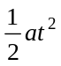, the acceleration can be found using the formula a = 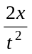.

A plot of acceleration versus sin θ should give a straight line with a slope equal to the acceleration due to gravity (g).

EQUIPMENT
• dynamics trolley with mass
• stopwatch
• dynamics track or board at least 1 metre long
• metre rule
• graph paper

Place a small piece of card, the size of a playing card, across an air-track glider to act as a reflector. If possible, make sure your motion sensor is set to ‘near’ to decrease the effect of stray echoes.

ICT
Sample rate: 10–20 Hz.
Graph: velocity versus time.
Calculate: acceleration for each trial.
Manual entry: graph of acceleration vs sin θ.

Increase the accuracy of the activity by measuring the acceleration of the cart with a motion sensor or photo-gates and graph the motion directly to a computer for analysis.

NOTES ON METHOD
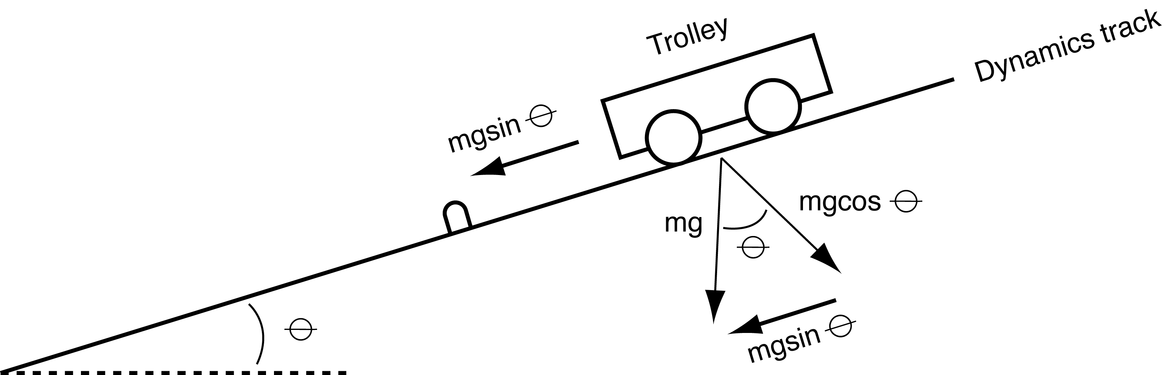

1. Set up the track as shown in the diagram, raising the end of the track where the trolley is to start at about 10 cm.

2. Pull the trolley up to the top of the track and record the initial position where the trolley will be released from rest.

3. Release the trolley from rest and use the stopwatch to time how long it takes the trolley to hit the end stop.
The person who releases the trolley should also operate the stopwatch.
Repeat this measurement 5 times (with different people doing the timing).
Record all the values in a suitable table.

4. Lower the end of the track by 1 cm and measure the time another five times.

15 Acceleration down an incline
continued

5. Repeat the experiment for a total of seven angles, lowering the track in increments of 1 cm for each new angle.

DATA & ANALYSIS
1. Calculate the average time for each angle.
2. Calculate the total distance travelled by taking the difference between the initial and final positions of the trolley.
3. Calculate the acceleration using the distance and times recorded with your data. Calculate and show these quantities automatically with your motion sensor data.
4. Measure the hypotenuse of the triangle formed by the track and use this to calculate sin θ for each of the heights.
5. Plot acceleration versus sin θ.
Draw the best-fit straight line and calculate its slope and g.

CONCLUSION
Comment on the relationship you found between acceleration and angle of incline.
What value did you obtain for g?
How does this compare with accepted values?
Can you account for any discrepancy?

QUESTIONS
1. Does your reaction time cause a greater percentage error for higher or lower angles?
2. If the mass of the trolley is doubled, how are the results affected? Try it.
3. Why was the angle of the track calculated from its length and height rather than by using a small protractor?

